AGENDA
Fish Passage O&M Coordination (FPOM) Team
April 15, 2010 (1230-1530)
St. Helens Room, NOAA Fisheries, Portland, OR

Conference line: 888-285-4585 FPOM code: 491747 Dykstra (Host) code: 476637

1. Review/Approve Agenda and March Minutes (Dykstra)

- Action Items
  - [Jan 10] MCN/IHR lamprey modification. ACTION: 2010 Lamprey modifications are complete.
  - [Mar 10] Unit slow roll. ACTION: Hausmann will chair a task group to look at more detailed criteria for slow rolling. He will provide an update at the April FPOM.
  - [Mar 10] NWW spill tables. ACTION: A task group to look at and work through the issues with the LMN and LGS spill tables has been created. Lorz suggested the 16th may be a good time for a face to face meeting. Dykstra would like to consult with S. Milligan. Tentatively, a meeting has been scheduled for 1330 on 16 March. NWW will call in. Dykstra asked that everyone read the email sent and take a look at the tables prior to the meeting.
  - [Mar 10] NWW spill tables. ACTION: FPAC will draft a change form to present to USACE on 16 March. Kiefer will send the comments to Dykstra and Moody (who will send it to Milligan).
  - [Mar 10] MCN Oregon ladder entrance gate operation modification. ACTION: NWW will write up a change form to incorporate the new condition.
  - [Mar 10] NWW cooling water strainer lamprey mortality. ACTION: Dykstra will take this issue to FFDRWG on behalf of FPOM.
  - [Mar 10] Smith Root UMT array. ACTION: Mesa will coordinate with University of Idaho to get radio codes.
  - [Mar 10] Smith Root UMT array. ACTION: S. Scott will talk with Smith-Root and BioMark to make sure there aren’t any issues with radio tags going through the array.
  - [Mar 10] May FPOM meeting. ACTION: Cordie will reserve the Westrick room from noon to 1600 on 13 May.
  - [Mar 10] MCN-JDA transmission line. ACTION: Bettin will put together a change form for the 2011 FPP.
  - [Mar 10] BON PH1 WG2 submergence limitation. BON Fisheries would like to test the ability to maintain differential and submergence during the summer months, when tailwater is below 13’. ACTION: Hausmann will coordinate the test for 15 March.
  - [Mar 10]PIT tag detection at the AFF. ACTION: CRITFC will provide drawings to FPOM by late summer so FPOM can review the plans.
  - [Mar 10] BON mid-season spillway outage for stilling basin survey. Schwartz requested a time between spring and summer as a placeholder for doing the survey. ACTION: Schwartz will provide a detailed write-up for FPOM to consider.
  - [Mar 10] Raising picket leads for lamprey. ACTION: If this goes forward, NWW will provide a change form.
  - [Mar 10] MCN false attraction in the collection channel. ACTION: NWW will provide a detailed description, a drawing and potential solutions.
  - [Mar 10] Freshwater sponges. ACTION: NWW will investigate further.

- Updates
  - MCN video monitoring plan. (Fryer)
  - LGS juvenile fish update
  - NWW Turbine cooling water strainer monthly update.
  - JDA deflector/testing. Coordination form attached.
  - JDA-N extended outage early heads up. Early coordination notification for JDAN outage for 2011/2012, for construction (entrance modifications). Initial dates are November 1 - March 15. Early November fish counts have not been summarized yet for fish impacts. A formal coordination request will be submitted. (Tackley)
  - JDA TSW operation.
  - JDA south fish pump outage. Maintenance will coincide with mid-season fishway inspection. Fish pumps will be out of service for one day.
  - TDA unit 3 and 4 outage. Notification form attached.
  - BON Spillbay 15 hoist. The spillway hoist is on the unfunded request (UFR) list.
  - BON spillbay 17 setting. Set at two dogs on 12 April.
  - BON PH1 WG2 submergence limitation.
  - Smith Root UMT array study plan
  - BON PH1 grizzlie drain modifications.
  - BON PH2 outage on 10 April- B2CC opening.
  - BON unit operation for Spring Creek fish releases.

- MCN Oregon fish ladder N and S traveling screens

- Potential FPP changes for the 2011 FPP.

  - BON 5.3 1% operation
  - BON 4.3.2.1.c.4 NDE operation
  - TDA 2.5.1.2.a.4 language about fishways below tailwater.
  - TDA 1.2.2.3
  - JDA 2.5.1.2.a.4 language about fishways below tailwater.
  - JDA 2.4.1.2.e VBS drawdown
  - JDA 1.2.2.3
  - MCN 2.3.1.2.c.2 orifice lights
  - MCN 4.2 turbine maintenance
  - MCN 3.2.2.3 South shore AWS system
  - MCN Table MCN-5 turbine priority at the end of spill season.
  - IHR 4.3 Turbine maintenance
  - IHR 2.3.1.2.a.2 screen drawdown
  - LMN 2.3.1.2.g RSW language
  - LMN 4.3 turbine maintenance
  - LGS 4.3 turbine maintenance
  - LGS 2.3.1.2.a.3 screen drawdown
  - LWG 3.2.2.2 AWS system
  - LWG 4.3 turbine maintenance
  - LWG 2.3.2.2.n adult trap
  - LWG Table LWG-4 counts
  - Change form from Bettin for MCN-JDA transmission line.

- 2011 FPP change forms drafted.
  - 11 IHR 0001 Primary Dewatering Procedures Change
  - 11 LGO 0001 spill table.
  - 11 LMN 0001 2010 spill table.

- PIT tag detection at the AFF. (J. Fryer)

- BON mid-season spillway outage for stilling basin survey. (Schwartz)

- BONN B2CC closure. (Schwartz)

- TDA Avian lines 2010. (Cordie)

- May FPOM site visit to The Dalles Dam – agenda items – (Hevlin)

- JDA-N water up.
  - JDA Fish mortalities. (Zyndol) memo attached to the agenda.

- MCN false attraction.

- MCN freshwater sponges

- Draft Kelt Management Plan. No presentation is anticipated at FPOM, however April 15 was the stated deadline for receiving comments from the region.

- IHR Diffuser 12 Status

- Other

- Next FPOM meeting
  - 15 April 2010- FPOM meeting at NOAA, after SCT. 1230 – 1530.
  - 15 April 2010- unit slow roll task group after FPOM.
  - 13 May 2010- 0900-1200 at JDA. Meet at SMF. 1300 – 1600 at TDA Westrick room.
DETAILED STUDY PLAN

Video Monitoring of Adult Fish Ladder Modifications to Improve Pacific Lamprey Passage at the McNary Dam Oregon Shore Fishway, 2010.

Period covered: January 20, 2010 to March 31, 2011

Principal investigator: Frank Loge

Assisting personnel: Donald E. Thompson, Staff Research Associate
Kai Eder, Research Scientist
Brian Klein, Computer Resource Specialist
Chris Caudill, Research Scientist
Chuck Boggs, Research Support Scientist II
Travis L. Dick, Senior Scientific Aid
Dan L. Joosten, Senior Scientific Aid
Steven R. Lee, Senior Scientific Aid
Duane Edgington, Software Engineering Group Leader
Danelle Cline, Software Engineer
Chris Peery, Fisheries Scientist

Background

The fishway at McNary Dam is comprised of a series of tilting weirs with orifices located several feet above the fishway floor. The purpose of these orifices is to allow passage of migrating salmon and steelhead, but the elevated location relative to fishway floor may pose passage problems for migrating Pacific lamprey. The Walla Walla District Army Corps of Engineers is planning to make modifications to the tilting weirs in order to both reduce delay and improve passage of lamprey. A total of seven stem walls supporting the tilting weirs will be modified to include “lamprey orifices”, which are essentially two orifices per stem wall, cut flush with the floor of the fishway, and measuring 3 inches tall by 18 inches wide. In addition to the lamprey orifices, metal plating will be installed over the top of three diffuser gratings to aid in lamprey attachment and passage.
Using underwater infrared cameras, video surveillance of three of these modified weirs will be used to assess whether: 1) passage of migrating salmon and steelhead is delayed or fish are injured by these orifices either by being attracted to or trying to pass through them, and 2) Pacific lamprey approach, enter, and successfully pass through the modified orifices. Initially, only two modified orifices will be monitored during the early spring Chinook salmon run, while the remaining orifices will be blocked. If no alteration in salmon and steelhead behavior and injury to salmon or steelhead occurs, subsequent modified orifices will be opened and examined using similar video surveillance.
Video footage of lamprey passage through these orifices will provide new information on how these animals pass through fish structures at high water velocities, and will aid in future construction improvements aimed at improving passage success for Pacific lamprey.

Objectives

1. Install six infrared underwater video cameras to monitor fish and lamprey passage at the first three modified stem walls and associated tilting weirs, and at diffuser plating.

2. Monitor video footage of migrating adult salmon and steelhead in the vicinity of modified orifices to analyze whether their passage is negatively affected, and observe the behavior of adult lamprey as they pass through the new orifices and across modified diffuser plating.

Camera selection and installation

Camera, lights, and track installation: Cameras will be installed during the winter maintenance period, currently scheduled to end 26 February 2010. University of Idaho crew will fabricate and install camera mounting systems for each camera location, allowing the camera to be positioned adjacent to the orifices on tilting weir stem walls. Cameras will be positioned within a moveable mount sliding on an aluminum I beam Hilti-bolted to the lateral aspect of the fishway wall. Camera cabling will be housed in conduit to increase durability. The placement of cameras will change throughout the study period to address a) the effects of orifices on salmon and steelhead passage, and b) lamprey behavior and passage performance at orifices. Initially, four cameras will be placed at two orifices of one modified weir (336) to maximize the field of view necessary to determine and compare presence, passage attempts, and delay of salmonids at a closed and open orifice. The first camera will be pointed toward the orifice and will provide a field of view of approximately 49 degrees (Figure 1). The additional camera will expand the field of view to approximately 98 degrees (inclusive of both cameras). Placement of cameras will be as follows:
- Two cameras installed on one track monitoring the entrance and downstream portion of the north orifice of Weir 336. This orifice will be closed during the salmonid migration portion of this study.
- Two cameras installed on one track monitoring the entrance and downstream portion of the south orifice of Weir 336. This orifice will be open during the salmonid migration portion of this study.
Depending on the outcome of the study of orifice effects on salmon and steelhead passage, all lamprey orifices will be open as the lamprey run starts at McNary Dam. Camera placement will be adjusted to address lamprey passage:
- One camera monitoring the entrance to the south orifice of Weir 335.
- One camera monitoring the entrance to the north orifice of Weir 336.
- One camera monitoring the entrace to the south orifice of Weir 336.
- One camera monitoring the entrance to the north orifice of Weir 337.
- One camera monitoring the entrace to the south orifice of Weir 337.
An additional camera will be mounted to view the modified diffuser grating plating at Diffusers 12-14. This camera will differ from the other 5 in that it will not be linked to the network (as described below), will not be monitored daily, and will be powered by a contractor provided gas generator.
An additional IR light source for nighttime and low light viewing will be placed next to each camera using custom mounting brackets. These auxiliary lights will augment the cameras built-in IR light source.
Camera performances will be evaluated during preliminary trials prior to the run season, and final camera selection will be based on performance and cost. During these trials (in-water period), cameras will be submerged to their working location and subsequently evaluated using a portable monitor during both day and nighttime, and with and without auxiliary IR lighting.

Camera maintenance: Cameras will be inspected weekly during the entire run season (1st week of April through mid-October). Maintenance will include, as necessary, cleaning camera lenses; servicing and adjusting camera positioning; and repairing or replacing camera mounts, cameras, and cabling to the extent possible during the in-water period.

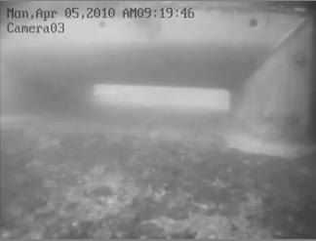

Figure 1. Visual field of one camera directed toward the orifice (south orifice of Weir 337)

Video monitoring

Camera link-up: BNC cable ends from cameras will be routed to a box located under stairs leading to fishway which houses a specialized network capable digital video recorder (DVR) and associated backup drive. Cables will be routed to not interfere with gantry crane path and covered over thresholds to prevent tripping hazards. For internet connectivity, a 1.2 m Hughes satellite dish will be mounted to the railing just north of the stairwell and the data transmission cables connected to the DVR.
Prior to use, all powered devices (cameras, lights, DVR, and cooling fans) will be provided to PSMFC for testing for possible electrical interference with the PIT tag detection hardware. If any interference is observed, appropriate line filters will be employed as needed.

Video data transmission: Video data will be collected from initially four and subsequently all five cameras during the time frames listed in Appendix A. Video data will be collected and recorded on site using the DVR, and backed up automatically with an external hard drive. Video data will be transmitted from the DVR to a network server at UC Davis via the Hughes satellite dish (transfer rate of up to a total of 1 gigabyte (GB) per day). Using a DVR bandwidth calculator, we estimate that 5 cameras running 10 hours per day at a frame rate of 3 frames per second (FPS) will result in a daily data file size of 500 MB (50% of the maximum daily transfer rate). These specifications are adequate for viewing fish behavior at orifices, and we will increase FPS (resolution) as needed to provide the best possible video quality while remaining within the maximum daily data transfer rate.
In addition to providing a network link to UC Davis, the connection will also allow for remote commands to be sent from UC Davis to the DVR via a remote desktop connection. Examples of such commands are: (1) external drive backup, (2) modification of camera settings (e.g., image-collection time, FPS, resolution), and (3) file retrieval (as described below).

Video processing: Using a video data transfer rate of 768 kbps, 500 MB of video data will be uploaded to UC Davis in approximately one and a half hours. To perform this transfer, the network drive on the DVR will be mapped to the server at UC Davis, and the file(s) of interest will be dragged from the DVR to the UC Davis computer. As an example: video taken on a Sunday will be stored to a folder called XX camera 1. Monday morning this folder, XX camera 1, will be moved to the UC Davis server by utilizing remote connection software. After approximately one and a half hours of download time (assuming 500 MB), the video file will be subsequently analyzed and summary statistics generated. Any video observations of fish behavior deemed to present a passage problem (description to follow) will thus be made available to the Corps biologists within 24-36 hours of the event. These reports are described below under Deliverables-reporting to USACE.

AVED video processing: A LINUX-based seven node parallel computing system will run Automated Visual Event Detection (AVED) software. Video files will be first converted to the proper format for processing, and then using a set of neuromorphic visual algorithms (an electronic analog set of formulas that mimic visual processes) the software will be “trained” to detect events of interest (e.g. fish attempting passage). After a series of customized image processing steps, the video file will be automatically marked for later manual observation. Processing of video in this manner will greatly reduce the amount of time needed to manually screen the files in their entirety. Pending successful marking of the video files, the suitability of the software to perform advanced image recognition will be explored. Using this feature, biological items of interest (salmon, lamprey) may be identified automatically. The software has been successfully used to do both of these tasks in underwater marine environments (Cline, et al. 2007).

Summary statistics of video observations at lamprey passage orifices

Overview: The purpose of video monitoring the new lamprey orifices at the three furthermost downstream tilting weirs is to a) ensure that the new lamprey orifices do not delay or harm ESA listed migrating salmon and steelhead, and b) determine lamprey usage of new orifices and passage efficiency.
The high velocity environment at the new lamprey orifices may attract other migrating fish such as salmonids, thus possibly extending their stay in the fishway. To determine if salmonids are attracted to open orifices, and how much time these fish spend in the immediate vicinity of open orifices, we will count salmon and steelhead present at an open and closed lamprey orifice, and the amount of time they spend at each location. A significantly greater fraction of fish at an open orifice and/or extended stay at an open orifice in comparison to a closed orifice may indicate a delay in migration for a particular species/run. Furthermore, narrow orifices designed for lamprey may cause injury to salmon and steelhead trying to enter or pass through. For the purpose of this study, any behavior indicating a passing attempt, such as a surging acceleration towards the orifice with touching the weir or orifice steel inserts will be interpreted as an attempt. To assess the risk of harm of fish species/runs at lamprey orifices, we will calculate the proportion of fish attempting passage at an open lamprey orifice.
New orifices were installed to improve upstream lamprey passage. One goal of this video monitoring study is to determine the proportion of lamprey at the new orifices. Therefore, the number of lamprey observed at each monitored orifice will be recorded and divided by the total visual lamprey counts at the south shore facilities of McNary Dam. However, since all monitored orifices are not identical, and a structural difference of the most downstream orifice at weir 335 (part of the stem wall remained) may affect lamprey passage success, we will compare lamprey passage and behavior at all monitored orifices. Specifically, we will determine the number of attempts lamprey make to pass each orifice and the amount of time lamprey spend on average at each orifice, and calculate the proportion of successful passes through each orifice. A passing attempt will be recorded when burst swimming directed toward the open orifice occurs. Lamprey passage efficiencies, here defined as the proportion that successfully pass a particular orifice, will be established for each monitored new orifice. The average time a lamprey spends in the vicinity of an orifice will be calculated by dividing the cumulative time spent by the number of lamprey present at each orifice. Comparisons of passage attempts, passage efficiencies, and average time at each monitored orifice will be used to identify passage differences between orifices. For example, a significantly smaller fraction of lamprey successfully passing through the orifice at weir 335 in comparison to the other orifices may indicate that the remaining stem wall poses a potential passage problem for lamprey. Similarly, significantly fewer attempts to pass or significantly more time spent at the orifice at weir 335 in comparison to other orifices may be an indication for a potential passage problem or a passage delay at this particular weir.
We will manually observe all collected video data for the presence and behavior of fish, and generate daily statistics as well as weekly, mid-season, and final summary statistics. Summary statistics will be provided to the U.S. Army Corps of Engineers in addition to edited video of fish interactions at the orifices.

Visual counts at McNary Dam: Information obtained at the visual counting window at McNary Dam will be used to generate summary statistics to assess salmon and lamprey interactions at the lamprey passage orifices. Visual counts, recorded by fish count technicians 16 hours per day (between 0400 – 2000 PST), 7 days a week, will start on April 1, 2010 at the fish counting station at the Oregon shore fish ladder of McNary Dam, and last through October. In addition, the U.S. Army Corps of Engineers conducted video counting for night lamprey activity and passage between June and September at various projects, including McNary Dam in 2009. Starting on June 15, 2010, lamprey counts will be taken for 8 hours each night (between 2000 – 0400), 7 days a week until September 30. Hourly adult fish counts (salmon, steelhead, shad and lamprey) will be recorded and totaled in a daily summary form delivered to a supervisory biologist to provide a daily passage estimate for each species/run. The visual counts will not be performed specifically as part of this study, but rather the data will be used as part of our analyses in this study.

Summary statistics for salmon, steelhead, and shad: Starting in early April, we will begin to video monitor fish activity at the entrance and downstream portion of the open south orifice of Weir 336, and at the entrance and downstream portion of the closed north orifice of Weir 336 for 6 hours per day (between 0700 – 1300), 5 days a week (between Sunday and Thursday; Table 2). Initial video data from each lamprey orifice will focus on adult salmon, steelhead, and shad and will be interrogated for 1) the number of fish present in the field of view of the cameras; 2) the number of attempts to pass, and 3) cumulative time spent in the field of view of the cameras (in seconds; Table 1). Completed daily summary forms from fish count technicians will be used to determine hourly counts made at the visual counting station during the time period of orifice monitoring.
To determine if salmonids are attracted to lamprey orifices, the number of fish present at the two video monitored orifices during the daily observation period will be recorded, and divided by the six-hour visual summary count. This proportional presence of salmonids at each orifice will be used to assess differences of fish presence at the open and closed orifice. Data will be analyzed for statistical significant differences with the Two Independent Proportions test using the Number Cruncher Statistical Systems (NCSS, Kaysville, Utah; Table 1). A significantly greater presence of salmonids at the open lamprey orifice in comparison to the closed orifice may be an indication for fish being attracted to operating lamprey orifices, which may negatively impact salmonid passage through the fishway.
In addition, we will assess how much time individual fish from each species/run spend in the immediate vicinity of the open and closed orifice. Time spent at each orifice will be recorded and added up daily for each species/run, and an average time per fish at each orifice will be calculated by dividing the cumulative time spent by the number of fish present during the respective observational period. To establish if fish spend a significantly different amount of time at the open and closed orifice, average times at each orifice for each species will be compared with One-Way Analysis of Variance (ANOVA) using NCSS (Table 1). Spending significantly more time at the open orifice may negatively impact salmon passage through the fishway by delaying migration.
Finally, we will identify fish species/runs attempting to pass through the new lamprey orifices since passage may cause injury for species/runs other than lamprey. The daily number of passing attempts, for his study defined as a surging acceleration towards the orifice with touching the weir or orifice steel inserts, will be recorded for each species/run. To determine the proportion of fish from each species/run attempting to pass, the number of attempts will be divided by the six-hour visual summary count. To assess which fish species/runs are at the highest risk of getting injured in lamprey orifices, calculated proportions will be compared statistically for differences with the Two Independent Proportions test using NCSS (Table 1). Data will be made available to the Corps POC and biologists to determine acceptable/unacceptable passage attempt rates for salmonids and shad.
All species/runs of interest for this study will be analyzed separately. Upon opening orifices in a sequential manner as planned, comparisons will temporarily include three open (south orifices of Weir 335, 336, and 337) and two closed orifices (north orifices of Weir 336 and 337), and finally five open orifices. Data collection and statistical analyses will be summarized for weekly, in-season (after the estimated video monitoring period for each species/run; Table 2), and final reports.

Summary statistics for lamprey: Starting June 6, 2010, we will begin to video monitor lamprey activity at five open orifices (weirs 335, 336, and 337) for 6 hours per night (between 2200 – 0400), 5 days a week (between Sunday and Thursday; Table 2). Video data from each orifice will be interrogated for 1) the number of lamprey present in the field of view of the camera; 2) the number of attempts to pass; 3) successful and unsuccessful passage, and 4) cumulative time spent in the field of view of the camera (in seconds; Table 1). Completed daily summary forms from fish count technicians will be used to determine hourly counts made at the counting station during the time period of orifice monitoring (2200 – 0400) as soon as data will be available. The visual counts will not be performed specifically as part of this study, but rather the data will be used as part of our analyses in this study.
To determine the usage of the new orifices by lamprey, the number of lamprey present at each video monitored orifice during the observation period will be recorded and divided by the six-hour visual summary count. This proportional presence of lamprey at each orifice will be used to assess differences of presence between orifices. Data will be analyzed statistically with the Two Independent Proportions test using NCSS (Table 1). Results may help to identify lamprey preference or avoidance of certain orifices or their structural differences, such as the remaining stem wall at weir 335.
To assess the feasibility of passing the new orifices, passing attempts at each orifice will be counted during the observational period and categorized as successful or unsuccessful. A passing attempt will be recorded when burst swimming directed toward the open orifice occurs, and will be only classified as successful when the entire body has passed through the orifice. To determine the rate of passage attempts for each orifice, the number of passing attempts at each orifice during the observational period will be divided by the number of lamprey present at that particular orifice. The statistical comparison of passage attempt rates between orifices may help identify certain structural differences or the location of a specific orifice with an impact on lamprey migration. Statistically significant differences will be determined with the Two Independent Proportions test using NCSS (Table 1). Furthermore, we will count successful and unsuccessful passage attempts and determine passage efficiencies by dividing the number of successful passes by the total number of attempts. The statistical comparison of orifice passage efficiencies will be performed with the Two Independent Proportions test (Table 1), and may help identify orifices with structural features promoting lamprey passage.
Finally, we will assess how much time lampreys spend in the immediate vicinity of orifices. Time spent at each orifice will be recorded for each lamprey and added up daily, and an average time per individual at each orifice will be calculated by dividing the cumulative time by the number of lamprey present during the respective observational period. To establish if lamprey spend significantly different amounts of time at different orifices, average times at each orifice will be compared with One-Way Analysis of Variance (ANOVA) using NCSS (Table 1). Spending a significantly greater amount of time at a specific orifice may indicate negatively impacted lamprey passage through the fishway by delaying migration.
Data collection and statistical analyses for lamprey passage and behavior will be summarized for weekly, in-season (after the estimated video monitoring period for lamprey; Table 2), and final reports.

Table 1. Anticipated observations and analyses at monitored lamprey orifices.

Fish species/run | Orifice  observation | Observational period | Fishway observation | Analyses | Orifice comparisons and statistical procedure
Spring, Summer, Fall Chinook salmon, Sockeye Salmon, Steelhead, Shad | 1. # of fish present (n_{P})  2. # of attempts to pass (n_{A}) | In hourly increments,  6 h/day | Total daytime count (n) for matching hours | 1. Presence (P) = n_{P}/n  2. Attempts (A) = n_{A}/n | P_{(open)} vs. P_{(closed)}  A_{(species x)} vs. A_{(species y)}  Two Independent Proportions test
Spring, Summer, Fall Chinook salmon, Sockeye Salmon, Steelhead, Shad | 3. Cumulative time spent (t_{cum}) | In hourly increments,  6 h/day |  | 3. Delay (D) = t_{cum}/n_{P} | D_{(open)} vs. D_{(closed)}  ANOVA
Pacific lamprey | 1. # of lamprey present (n_{P})  2. # of attempts to pass (n_{A})  3. Passage success (n_{S}) | In hourly increments,  6 h/day | Total nighttime count (n) for matching hours | 1. Presence (P) = n_{P}/n  2. Attempts (A) = n_{A}/n_{P}  3. Efficiency  (E) = n_{S}/n_{A} | P_{(orifice x)} vs. P_{(orifice y)}  A_{(orifice x)} vs. A_{(orifice y)}  E_{(orifice x)} vs. E_{(orifice y)}  Two Independent Proportions test
Pacific lamprey | 4. Cumulative time spent (t_{cum}) | In hourly increments,  6 h/day |  | 4. Delay (D) = t_{cum}/n_{P} | D_{(orifice x)} vs. D_{(orifice y)}  ANOVA

Determination of video monitoring dates

Cumulative fish passage at Bonneville Dam, located approximately 235 km downstream from McNary Dam, and at McNary Dam will be monitored through the Columbia River DART (Data Access in Real Time) website (http://www.cbr.washington.edu/dart/dart.html) for all species of concern to determine exact video monitoring periods during times of interest (Figures 1A through G). Monitoring adult passage at Bonneville Dam will allow early estimates of the timing and size of each run; these estimates will enable predictions of arrival and numbers at McNary Dam.
For salmonids and shad, we anticipate video observations from each species during early and peak passage, totaling approximately 25% of the annual count. Due to anticipated low numbers of returning adult lamprey, we plan to cover 90% of the total annual count.
We intend to capture the early passage of each species and run (salmonids and shad), defined herein as the passage of the first 10% of the total annual count. Total counts for each run will be estimated using 10 year passage count averages at McNary Dam and daily counts at Bonneville Dam provided by DART. In order to determine a conservative start date for video surveillance (Table 2), the earliest arrival of the first 1% of each run at McNary Dam over those 10 years was selected (Figure 3). Due to relatively warm river water temperatures for the month of March, it is anticipated that the spring Chinook run may arrive earlier than this date (Keefer et al., 2008). Monitoring of the early passage will be terminated when approximately 10% of each species has passed through.
We will also monitor the peak passage of each species (salmonids and shad), defined herein as the passage of 40 to 60% of the total adult counts. To provide a conservative approach, start times for video surveillance (Table 2) were calculated using the earliest passage of 50% of the total adult count at McNary for each run over the past 10 years (Figure 3). Monitoring of peak passage will end after 60% of each species have passed through (Table 2).
For lamprey, start and end dates of monitoring (Table 2) were determined using the earliest passage of the first 1% and the latest passage of 90% of the total adult counts at McNary.
Figure 2A. 10 Year Historical Run Timing Lamprey Passage at Bonneville Dam

Figure 2B. 10 Year Historical Run Timing Adult Spring Chinook Salmon Passage at Bonneville Dam
Figure 2C. 10 Year Historical Run Timing Adult Summer Chinook Salmon Passage at Bonneville Dam
Figure 2D. 10 Year Historical Run Timing Adult Fall Chinook Salmon Passage at Bonneville Dam
Figure 2E. 10 Year Historical Run Timing Steelhead Passage at Bonneville Dam

Figure 2F. 10 Year Historical Run Timing Shad Passage at Bonneville Dam
Figure 2G. 10 Year Historical Run Timing Sockeye Salmon Passage at Bonneville Dam

Figure 3. 10 Year Historical Run Timing* and 10 Year Average Count of Select Species Passage at McNary Dam

Table 2. Schedule for video monitoring of modified orifices.

Species/Run | Early Passage  Start Date | Peak Passage Start Date | Estimated Video Monitoring Period | Monitoring Frequency | Time of Day
Spring Chinook | April 3 | April 24 | April 3 - May 21 | Sun. - Thurs. | 07:00-13:00
Summer Chinook | June 8 | June 25 | June 8 - July 07 | Sun. - Thurs. | 07:00-13:00
Fall  Chinook | Aug. 11 | Sept. 6 | Aug. 11 – Sept. 24 | Sun. - Thurs. | 07:00-13:00
Steelhead | June 30 | Sept. 14 | June 30 – Oct. 04 | Sun. - Thurs. | 07:00-13:00
Shad | May 26 | June 18 | May 26 – July 07 | Sun. - Thurs. | 07:00-13:00
Sockeye | June 10 | June 26 | June 10 – July 07 | Sun. - Thurs. | 07:00-13:00
Lamprey | June 6 | July 28 | June 6 - Sept 21 | Sun. - Thurs. | 22:00-04:00

Deliverables - reporting to USACE

Outside of a final report, a series of reports will be generated from this study and are listed in Appendix A of this study plan. This section describes in detail each of those reports.

Summary videos. These video excerpts of fish behavior will be edited by the contractor to demonstrate problems associated with the passage of salmonids and will be provided to the Corps via a web link. Once the link is accessed, the video clip will be available for viewing, as will a full written description of the event (e.g. which orifice, what time of day, species, specific behavior, and associated daily summary statistics). This information will be embedded within the website and will be easily identified with the associated video clip. The frequency of these reports will depend on observational data from the cameras

Weekly reports. A summary video with a written description of important events such as salmon passage problems will be presented to the Corps POC on a weekly basis. Observations and interpretations will be supported by summary statistics as outlined under ‘Summary statistics of video observations at lamprey passage orifices’.

In-Season reports. In season reports will be presented to the Corps POC after summary videos and statistics are completed for specific species/runs. The first in-season report is expected to contain a summary video, summary statistics, and a written description and interpretation of the data presented for Spring Chinook salmon.

Responsibilities

Frank Loge, Principle Investigator
Duties: Project planning, and administration, and reporting.

Christopher C. Caudill, Research Scientist
Duties: Responsible for budgeting, supervising, and coordinating installation and maintenance of cameras at McNary Dam.

Donald E. Thompson, Staff Research Associate
Duties: Project manager. Draft study plan; ensure schedule is followed according to plan. Procure video equipment and supervise installation. Supervise video data collection and reporting of video data. Assist with report preparation.

Kai Eder, Research Scientist
Duties: Draft study plan. Collect and analyze video data, assist with reporting.

Brian Klein, Computer Resource Specialist
Duties: Provide IT support, set up and maintain network and server, assist with installation of video recording equipment.

Duane Edgington, Software engineering group leader (MBARI)
Duties: Provide oversight for AVED analysis

Danelle Cline Software engineer
Duties: Set-up and installation of AVED software, training of staff for use.

Steven R. Lee, Senior Scientific Aid
Duties: Procure equipment and supervise collection and processing of field data and seasonal staff. Ensure sampling and schedules follow methods prescribed in the Operational Plan. Assist with capturing and tagging adult Lamprey.

Travis L. Dick, Senior Scientific Aid
Duties: Responsible for camera installation and maintenance.

Chuck Boggs, Research Support Scientist II
Duties: Responsible for design and installation of temporary camera tracks and installation of cameras.

Dan C. Joosten, Senior Scientific Aid
Duties: Responsible for camera installation and maintenance.

Chris Peery, Fisheries Scientist
Duties: Provide assistance with camera selection, data analyses, and reporting.
References

Cline, D.E., Edgington, D.R., Mariette, J. 2007. An Automated Visual Event Detection System for Cabled Observatory Video. MTS/IEEE Oceans 2007 Conference Proceedings, Vancouver, Canada. IEEE Press.

Columbia River DART (Data Access in Real Time). 1993. Columbia Basin Research, School of Aquatic and Fishery Sciences, University of Washington, Seattle. Available: http://www.cbr.washington.edu/dart/dart.htm.

Keefer, M.L., Peery, C.A., Caudill, C.C. 2008. Migration timing of Columbia River Spring Chinook salmon: effects of temperature, river discharge, and ocean environment. Transactions of the American Fisheries Society 137:1120-1133.

Appendix A. Schedule of tasks and reporting

Final results from this study will be published in report to the U. S. Army Corps of Engineers (USACE), Walla Walla District on Jan 31, 2011 (Draft) and March 31, 2011 (Final).

Task | Time frame | Responsibility
Camera and track installation | Feb 15-Feb 26 2010 | CCC, CB, DLJ, TLD, SRL
Order video recording equipment | Feb 16-Feb 26 2010 | DET, BK
Camera testing and evaluation | March 1-10, 2010 | SRL, DLJ, TLD, CP
Link cameras to video equipment | March 23-March 30 2010 | DET, BK, CB, SRL
Camera maintenance | April-Oct 2010 | DET, KJE, CB, TLD
Orifice video observations | April 3-Sept 27 2010 | DET, KJE
Video processing and analysis | April 3-Oct 2010 | DET, KJE
AVED set up and video processing | May 1-Oct 2010 | DET, KJE, DE, DK
Removal of cameras and equip. | Oct 2010 | DET, CB, DLJ, SRL
Summary videos | April 12-Sept 29 2010 | DET, KJE
Weekly reports | April 19-Oct 1 2010 | DET, KJE
In-season reports | April 19-Oct 1 2010 | DET, KJE
Draft completion report | 31 Jan 2011 | CCC, DET, KJE
Completion report | 31 March 2011 | CCC, DET, KJE

Appendix B. Camera, video, and networking specifications.
Item | Supplier | Model No. | Specifications
IR underwater camera | Speco Technologies | CVC-320WP | 1/3” CCD image sensor  0 lux minimum illumination w/ 8 IR LEDs
IR auxiliary lights | SeaViewer Cameras | SeaLight | 42 IR LEDs w/ 50’ cable and 110AC transformer
Standalone DVR | Opt Web Properties | Custom build | 8 Ch. input, 8 TB SATA-2 drive, Windows XP PRO, 4 GB DDR2 memory
External Hard Drive | Buffalo | HD.W10TIU2/R1 | 2 TB SATA-2 drive
Hughes satellite dish | Andrew Communications | HN9000 | 2 Watt radio, 512-1,024 kbps upstream speed.

Appendix C. List of contacts at Army Corps of Engineers Walla Walla District office and McNary Dam.

Walla Walla District office

Derek Fryer: (509) 527-7280. Derek.S.Fryer@usace.army.mil

McNary Dam

Brad Eby: (541) 922-2263. Brad.W.Eby@usace.army.mil
OFFICIAL NOTIFICATION FOR
NON-ROUTINE OPERATIONS AND MAINTENANCE

NOTIFICATION DATE- 6 April 2010
PROJECT- The Dalles Dam
RESPONSE DATE- No response required, but comments are always welcome.

Description of the problem- The Dalles unit priority for units 3 and 4; Per Fish Passage Plan, unit operation priority are 1 and/or 2 and 3 and/or 4 during juvenile fish passage season for optimal attraction to the sluiceway. Due to contract repairs on T2 transformer (connected to units 3 and 4), these units are required to remain off through about 3 May. Units 1 and 2 will remain in operation during this outage.

Type of outage required- Unit 3 and 4 out of service through May 3.

Impact on facility operation- Units 3 and 4 out of service.

Length of time for repairs- Through 3 May.

Expected impacts on fish passage- No impact is expected. Unit 3 and 4 priority was established to allow flexibility with units 1 and 2 operation while still maintaining sluiceway attraction. We will require 1 and 2 to remain on during this outage, it should make up for the outage of 3 and 4.

Peak passage for yearling Chinook and steelhead are mid May. Peak passage for Coho and sockeye about 1 week later. Passage estimates through April from John PSMFC data ’08 and ’09 are ~140K -260K total salmonids which comprise of 15%-23% of total John Day Dam passage.

Comments from agencies-

Final results-

Tammy Mackey
NWP Operations Division Fishery Section
Columbia River Coordination Biologist
541-374-4552 Bonneville Office
503-961-5733 Blackberry
Tammy.m.mackey@usace.army.mil

OFFICIAL COORDINATION REQUEST FOR
NON-ROUTINE OPERATIONS AND MAINTENANCE

COORDINATION DATE- 6 April 2010
PROJECT- John Day Dam
RESPONSE DATE- 09 April 2010

Description of the problem- Installation of the new avian wire array at John Day Dam (JDA) has been delayed due to bad weather and a slip in the Bay 20 flow deflector schedule. The avian array installation is expected to be completed on Friday, but the ongoing balloon-tag injury and survival study has to shut down to facilitate this.

Type of outage required- Removal of the release pipes on April 12 requires temporarily switching to the FPP pattern (north bulked at 30%) and closing the TSWs.

Impact on facility operation- Spill patterns would be impacted for four hours on 12 April.

Length of time for repairs- Four hours to remove the pipe on 12 April.

Expected impacts on fish passage- Impacts to fish are expected to be minimal. Spill will still start as planned: 30% TSW pattern in Appendix A. The balloon-tag test will continue on April 10-11 under that spill pattern, but with a 4.0 Kcfs discharge from Bay 20 (the planned test condition that remains).

The removal of the release pipes will occur on April 12. Pipe removal will require temporarily switching to the FPP pattern (north bulked at 30%) and closing the TSWs. Once the pipes are removed, spill will return to the TSW pattern. The temporary switch in pattern and removal of the pipe is expected to take 4 hours, from 0900-1300.

Comments from agencies
NOAA- via telephone Fredricks said he was ok with the plan as outlined in this form.

Final results

Please email or call with questions or concerns.
Thank you,
Dennis

Dennis Schwartz
NWP Planning Bio
503-808-4779
Dennis.E.Schwartz@usace.army.mil

CENWP-OD-J
07 April 2010
MEMORANDUM FOR THE RECORD

SUBJECT: Dead steelhead at JDA-N.

On 7 April, JDA Project Fisheries reported four dead adult steelhead were found inside the north ladder. Three of the fish were located in the control section and the fourth was in the lower ladder (first pool at tailwater).

- Species – four steelhead
- Origin – Unknown
- Length – unknown
- Weight – Unknown
- Marks and Injuries noted during tagging – NA
- Marks and Injuries found on the carcass – NA
- Cause and Time of Death – late morning on 7 April 2010. These mortalities are a result of multiple ladder water ups and dewaterings which have been occurring since 2 April; these dewaterings were necessary for the contractor to keep fixing the leaking counting station window, broken crowder's hardware and correcting other minor deficiencies. In spite that the entrance weirs were closed to prevent entry of fish, a few must had been present inside the lower ladder pools and then moved upstream during the last water up yesterday, 4/6. The last dewatering happened late at approximately 1700 hrs on 4/6 so it was difficult to schedule a fisheries inspection or rescue operation.
- Future and Preventative Measures – As a result of these mortalities, Fisheries requested JDA operations and maintenance notify Fisheries, in advance, of any subsequent JDA-N ladder dewaterings. This will allow Fisheries to organize fish rescue operations, if needed.
- Other –

MIROSLAW A. ZYNDOL
JOHN DAY DAM
CHIEF OF FISHERIES
BB CELL : 541-980-9958

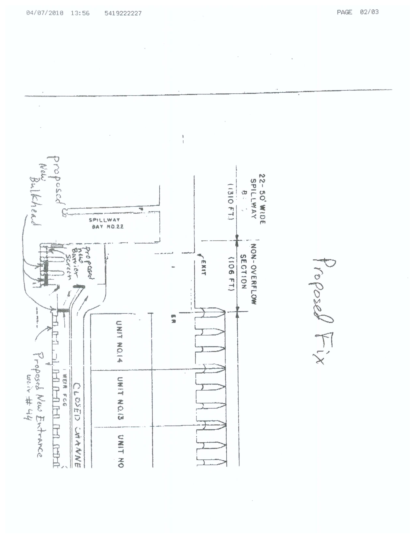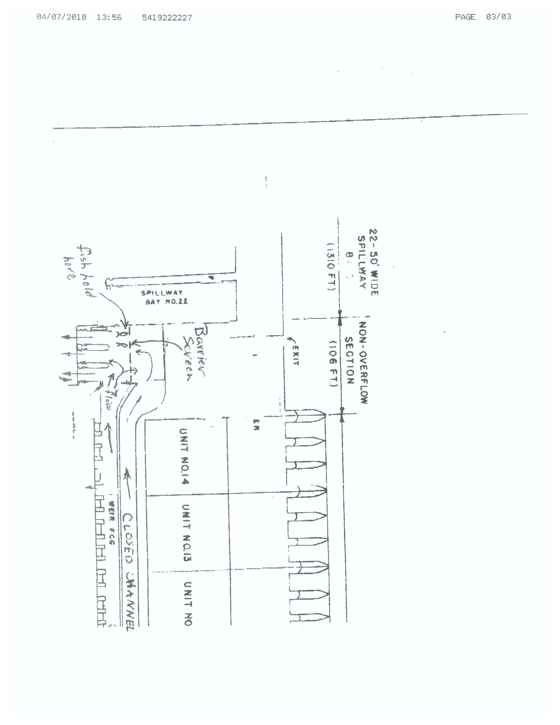
McNary Dam
Oregon Shore Fish Ladder Intake
Traveling Screen Replacement

25 March 2010

BACKGROUND.
The Oregon shore fishladder intake is screened by two traveling screens approximately 11 feet wide by 73 feet tall. The intake structure extends into the forebay near the Oregon shore. See photos at end of document. The screens were installed as part of McNary’s original construction back in the early 1950’s.

While the southern screen was repaired in the late 1990’s, neither has been replaced since installation. The northern screen is currently inoperable. Some screen panels (also referred to as baskets) are being replaced to hopefully operate another fish season. Although the southern screen is operable, it is difficult to predict how long it will operate. Project personnel speculate it may be difficult to make it through this fish season without major O&M concerns related to these screens. See photos at end of document for screen condition. It is considered vital to continued intake operation to have some type of repair/replacement in place by next fish season.

Approximately 1240 cfs flows through these screens for much of the fish passage season.
- 1000 cfs to the Oregon Shore Fishladder.
- 100 cfs to the McNary wildlife area.
- 140 cfs to the WEID canal between March and October.

Given the available screening area, average screen velocities are approximately 1.2 fps to 1.4 fps. The project fish biologist has observed a few subyearling chinook impinged on the screens over the past 20 years. In addition, several shad were also observed on the screens during August and September.

MESH DETAILS.
Repair or replacement-in-kind of existing screens would use a 1/16” diameter wire with 4 spaces per inch.
- Provides a 3/16” square opening (meets old fingerling screening criteria).
- Mesh is approximately 56% open area.
- Through screen velocities would be about 2.5 fps (screens are designed for through screen velocities of 2-2.5 fps).
- NMFS fry criteria of 1/16” square openings (3/16” diagonal openings) is not recommended for repair/replacement of existing screens.
  - Screen open area is approximately 25% open (with 1/16” diameter wires).
  - Through screen velocities reach 3.5 to 5 fps exceeding screen design criteria.

SCREEN REPAIR/REPLACEMENT OPTIONS.
- Repair Screens. Approximately $560,000 to repair both screens.
  - Repair both screens for long term operation.
  - Approximately $230,000 per screen plus $50,000 for first screen installation and $20,000 for second screen installation.
  - Above cost is for screens only. Also need project support, district and contracting support, etc – Approximately $100k. Total replacement is likely near $600-650k.
  - It may be possible to do less extensive repairs for shorter term operation (to get through 2-3 years), but it is not recommended.
    - Screens are large and in poor shape (see photos) making even less extensive repairs expensive (likely $150,000+ per screen).
    - Screen reliability would be much lower than with replacement (or more extensive repairs) which could jeopardize the intake water supply.
- Replace screens-in-kind. Approximately $600,000+.
  - Approximately $250,000 per screen plus $50,000 for first screen installation and $20,000 for second screen installation.
  - To replace both screens would be about $600,000 for screens only. Also needs project support, district and contracting support, etc – Approximately $100k. Total replacement is likely near $650-700k.
  - Screen openings would meet old fingerling criteria (less than ¼” in narrow direction).
  - Exceeds old fingerling average velocity criteria of 0.8 fps.
  - Provides most reliable Oregon shore fishladder water supply (as compared to screen repair).
- Redesign intake to meet old fingerling criteria. Approx. $8-15 million.
  - 1/4” clear openings, average velocity of 0.8 fps.
  - Extend intake structure to accommodate screening system to meet fingerling criteria.
  - Likely 3-5 years before complete.
  - Need to double screen area (4 screens of the existing size, for example).
  - Likely $8-15 million range (very rough estimate).
  - May not have dependable fishladder intake water supply prior to construction unless replace existing intake screens.
  - May lose intake water supply for one or more fish seasons during construction (unless supplement with pumps, etc.).
- Redesign intake to meet fry criteria. Approx. $15-30 million.
  - 3/16” diagonal openings, average velocity of 0.4 fps.
  - Extend intake structure to accommodate screening system to meet fry criteria.
  - Likely 3-5 years before complete.
  - Need to quadruple screen area (8 screens of the existing size, for example).
  - Likely $15-30 million range (very rough estimate).
  - May not have dependable fishladder intake water supply prior to construction unless replace existing intake screens.
  - May lose intake water supply for one or more fish seasons during construction (unless supplement with pumps, etc.).
- Biological Testing to determine intake impacts.
  - Likely $500-600,000 for hydroacoustics.
  - Likely $300,000 more for video work and bypass evaluation.

QUESTIONS.
- Can we replace the screens-in-kind?
  - Provides the most dependable intake water supply screening for the short term (or longer if intake not modified).
  - Nearly the same cost as repair.
  - If intake modified in the future and screens excessed, cost of replacement screens will be about 5-8% of projected intake cost (based on lower range of estimated costs).
- Is biological testing needed to determine impacts of intake screening system on fish population?
  - Information is only helpful if we decide to replace the intake structure.
  - What are reasonable chances we’ll replace the intake structure in the near future given the following:
    - Location of structure in relation to main river channel?
    - Total flow passing through structure as compared to total river flow?
    - Cost of replacement given other regional priorities?

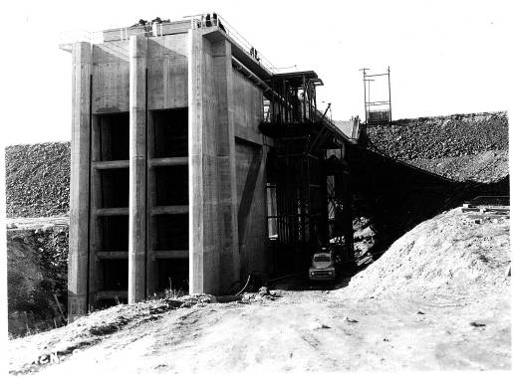

INTAKE STRUCTURE DURING CONTRUCTION
(See truck near bottom right for scale)

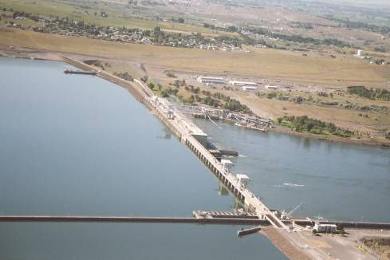

McNARY UPSTREAM AERIAL PHOTO (Intake circled in red)

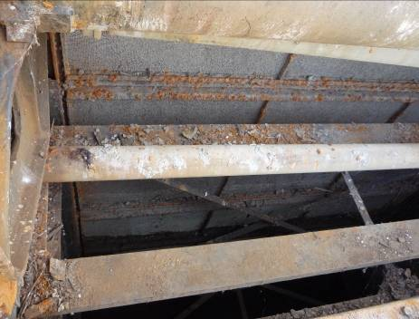

INTERIOR NORTH INTAKE SCREEN (Under repair)

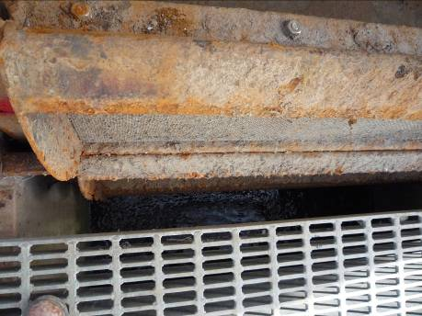

INTERIOR NORTH INTAKE SCREEN (Under repair)

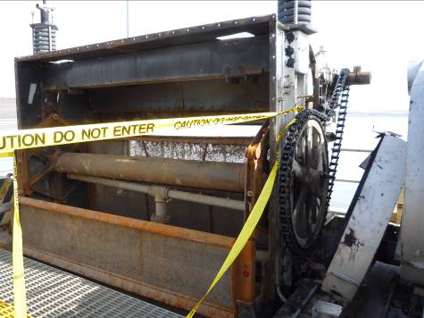

NORTH INTAKE SCREEN (Under repair)

March 2010
Sunday | Monday | Tuesday | Wednesday | Thursday | Friday | Saturday
 | 1 Adult Passage Season Begins –  Start counting at  Lower Granite Dam 2 | 2  NWD F&W conf.  FPAC | 3  NWD F&W conf. | 4  NWD F&W conf. | 5 | 6  Happy Birthday
7 | 8 | 9 FPAC | 10 | 11  FPOM meeting  TDA spillwall call | 12 | 13  BON kelt trigger met  Happy Birthday
14  BON B2CC open | 15  BON trolley pipe installation begins | 16 FPAC | 17 | 18 | 19 | 20
21 | 22 | 23 FPAC | 24 | 25  TDA spillwall call | 26 | 27
28 | 29 | 30 FPAC | 31

April 2010
Sunday | Monday | Tuesday | Wednesday | Thursday | Friday | Saturday
 |  |  |  | 1  Adult Fish Counting Starts all Dams.  Juvenile Bypass Season Begins | 2 Juvenile Spill Starts Snake River Dams – Pools to MOP  BON low forebay | 3  BON low forebay
4 | 5 | 6 FPAC | 7 | 8  FPOM meeting  TDA spillwall call | 9 | 10  Spill Starts  BON PH2 OOS- BPA  B2CC OOS
11 | 12 | 13 FPAC | 14 | 15 | 16 | 17
18 | 19 Snake River Juvenile Transport Begins  Happy Birthday | 20  FPAC | 21  TMT | 22  TDA spillwall call | 23 | 24
25 | 26 | 27  FPAC  Happy Birthday | 29 | 29 | 30

May 2010
Sunday | Monday | Tuesday | Wednesday | Thursday | Friday | Saturday
30 | 31 |  |  |  |  | 1
2 | 3 | 4  FPAC | 5  TMT | 6 | 7 | 8
9 | 10 | 11  FPAC | 12 | 13 FPOM Meeting- | 14 | 15
16 | 17 | 18  FPAC | 19  TMT | 20 | 21 | 22
23 | 24 | 25  FPAC | 26 | 27 | 28 | 29

PROPOSED FPP CHANGE FORMS

Change Request Number:
Date: February 5th, 2010
Proposed by: David Benner, FPC
Location of Change- BON 5.3
Proposed Change: 5.3. Turbines will be operated within +/-1% of best turbine efficiency from April 1 through October 31 (as specified in the BPA load shaping guidelines) except as specifically requested by BPA to do otherwise as provided in Appendix C.
Reason for Change: This section was confusing and seemed to imply that a unit operation other than +/-1% was allowable when the daytime spill cap is 75 Kcfs.
Comments from others:
USFWS- I support the following change forms.
BON Control Room Operators- He clarified the requirements for April 1 through October 31 but completely dropped the November 1 through March 31 time frame. I think the November 1 through March 31 requirements should still be addressed in this section.
BON Fisheries- The last sentence in this section (5.3) "However, during the rest of the year, the project will continue to operate units within the 1% turbine efficiency range, except as specifically requested by BPA to do otherwise as provided in Appendix C" should remain unchanged to address Brad's comment. Everything but "except as specifically requested by BPA to do otherwise as provided in Appendix C" had been removed in the change form.
NOAA- The proposed language is appropriate. We no longer have a 75 k cap except in late summer when there is no danger of excess spill.
CRITFC- agree with.
BPA has no concerns
Record of Final Action:
☺☺☺☺☺☺☺☺☺☺☺☺☺☺☺☺☺☺☺☺☺☺☺☺☺☺☺☺☺☺☺☺☺☺☺☺☺☺
Change Request Number:
Date: February 5th, 2010
Proposed by: David Benner, FPC
Location of Change- BON 4.3.2.1c4
Proposed Change: 4. If all auxiliary water systems fail or malfunction, close the NDE and SDE and floating orifice gates (if longterm outage). Operate both SUE and NUE to extent possible while still maintaining a minimum of 1 ft head differential. If a minimum of 6ft gate depth cannot be maintained at both SUE and NUE with a minimum of 1 ft of head differential- then close SUE and block collection channel (if possible) and operate NUE to maximum depth possible while still maintaining at least 1 ft head differential at NUE. While under this configuration, power generation at Powerhouse Two will be minimized to the extent practicable to reduce fish attraction into this area unless Powerhouse One facilities are dewatered.
Reason for Change: Under a long term outage, floating orifice gates should be closed to provide more water at other main entrances. The upstream entrances are closer to operating units, the attraction benefit from these units would be greatest at the upstream entrances.
Comments from others:
USFWS- I think these change forms need more discussion at FPOM.
BON Fisheries- Bon 18 is not realistic. Bon 18 should remain as current language. NDE is the most efficient entrance, according to the data, and the rest is speculation, unless there is data out there to support this. We have not seen it and the assumption of what can be achieved at the entrances is not valid.
CRITFC- need to discuss but might ok with
NOAA- 10BON018 Makes sense, and this has been recommended in the past. Needs discussion in FPOM and a review of adult approach and passage differences between the upstream and downstream entrance gates.
BPA has no conerns
Record of Final Action:
☺☺☺☺☺☺☺☺☺☺☺☺☺☺☺☺☺☺☺☺☺☺☺☺☺☺☺☺☺☺☺☺☺☺☺☺☺☺
Change Request Number:
Date: February 5th, 2010
Proposed by: David Benner, FPC
Location of Change- TDA 2.5.1.2.a.4
Proposed Language- 4. A water velocity of 1.5 to 4 fps (2 fps optimum) shall be maintained for the full length of the powerhouse collection channel and the lower ends of the fish ladders that extend downstream of the dam. Fishway channel water velocities will be measured three times weekly, daily preferred, during adult fish passage (Mar 1 – Dec 1) part of the fishway inspection program. Floats will be timed through all fishway channels that are supplemented by auxiliary water. Results will be provided in the project weekly fishway status report.
Reason for Change: The original language was confusing. At no point should the water surface of a channel be below tailwater (this would result in a negative head differential). Velocities are measured in the collection channel and in sections of the fishway that extend downstream of the dam.
Comments from others:
USFWS- I support the following change forms. I agree that the current language is confusing.
NWP Fisheries- the language is more awkward than the original.
NOAA- The ladders actually do go below tailwater but I don’t see any problem with the proposed language.
CRITFC- Might need to discuss but ok with if no one else has a problem
10TDA005 Ladder can go lower, but so what should be ok
BPA recommends this to be placed on an FPOM agenda for additional discussion
Record of Final Action:
☺☺☺☺☺☺☺☺☺☺☺☺☺☺☺☺☺☺☺☺☺☺☺☺☺☺☺☺☺☺☺☺☺☺☺☺☺☺
Change Request Number:
Date: February 5th, 2010
Proposed by: David Benner, FPC
Location of Change- TDA 1.2.2.3
Proposed Language: 1.2.2.3. Adult fish migration timing has been calculated for The Dalles Dam from count data collected by the Corps from 1957 through 2009. Table TDA-2 summarizes the count periods and the earliest and latest peaks of migration recorded for each species (except shad). Peak lamprey migration timing in table TDA-2 was calculated using the years 2000-2008.
Table TDA-2. The Dalles Dam adult count periods and peak migration timing, 1957-2009.
Species Count Period Earliest Peak Latest Peak
Spring Chinook 4/1 - 6/3 4/13 5/13
Summer Chinook 6/4 - 8/3 6/6 8/1
Fall Chinook 8/4 – 10/31 9/2 9/23
Sockeye 4/1 – 10/31 6/20 7/10
Steelhead 4/1 – 10/31 7/9 9/23
Coho 4/1 – 10/31 9/3 10/25
Lamprey 4/1 – 10/31 7/14* 8/1*
* Peak lamprey migration timing for only the years 2000-2008.
Reason for Change: The years that were used to estimate migration timing needed to be updated in the text. A footnote should be added to table that indicates that migration timing for lamprey were estimated using a different set of years than the other fish in the table.
Comments from others:
NWP Fisheries- by changing the first sentence, it creates another opportunity to have a date error. “since 1957” would suggest the data continues to be collected and the “through 2009” would not have to be updated each year.
USFWS- I support the following change forms.
NOAA- ok with language changes if these data even need to be in the plan. The plan could just refer to the Corps’ adult passage web page or the adult passage annual report.
CRITFC- agree with.
BPA has no concerns with this change
Record of Final Action:
☺☺☺☺☺☺☺☺☺☺☺☺☺☺☺☺☺☺☺☺☺☺☺☺☺☺☺☺☺☺☺☺☺☺☺☺☺☺
Change Request Number:
Date: February 5th, 2010
Proposed by: David Benner, FPC
Location of Change- JDA 2.5.1.2.a.4
Proposed Change: 4. A water velocity of 1.5' to 4 fps per second (2 fps optimum) shall be maintained in all channels and the lower ends of the fish ladders that extend downstream from the face of the dam. Floating orifice gates 1, 2, 18, and 19 will be open and three fish pumps will be operated to maintain fishway criteria.
Reason for Change: The original language was confusing. At no point should the water surface of a channel be below tailwater (this would result in a negative head differential). Velocities are measured in the collection channel and in sections of the fishway that extend downstream of the dam.
Comments from others:
JDA Project Fisheries- I don't have any comments since the change forms from Benner don't seem critical and/or urgent.
USFWS- I support the following change forms. I agree that the current language is confusing.
NWP Fisheries- not all sections of the lower ladder extend downstream from the face of the dam. The language is more awkward than the original.
NOAA- Ok with change.
CRITFC- agree with.
BPA recommends this to be placed on an FPOM agenda for additional discussion.
Record of Final Action:
☺☺☺☺☺☺☺☺☺☺☺☺☺☺☺☺☺☺☺☺☺☺☺☺☺☺☺☺☺☺☺☺☺☺☺☺☺☺
Change Request Number:
Date: February 5th, 2010
Proposed by: David Benner, FPC
Location of Change- JDA 2.4.1.2.e.
Proposed Change: e. Additional raking will occur whenever trash accumulations are suspected because of increased differential (1.5') across the trash racks (relative to a clean condition), or as determined by the project biologist in reference to indicators such as increased juvenile fish descaling at the dam, deteriorating fish condition as noted by SMF personnel, or increased accumulations of tumbleweeds in the forebay. Gatewell orifices of the unit being raked must be closed during the raking operation.
Reason for Change: This section needed a reference for “increased differential.”
Comments from others:
JDA Project Fisheries- I don't have any comments since the change forms from Benner don't seem critical and/or urgent.
USFWS- I support the following change forms.
NOAA- Gatewell drawdown. FPOM needs to review this. Is the normal drawdown already in the 1.5’ criterion (i.e., one half foot normal drawdown plus a one foot debris drawdown)?
CRITFC- Might need to discuss but ok with if no one else has a problem
Cordie- JD gatewell drawdown criteria limit is 1.5' The VBS criteria limit is 1.2' before we shut down and inspect for debris.
BPA has no concerns with this change
Record of Final Action:
☺☺☺☺☺☺☺☺☺☺☺☺☺☺☺☺☺☺☺☺☺☺☺☺☺☺☺☺☺☺☺☺☺☺☺☺☺☺
Change Request Number:
Date: February 5, 2010
Proposed by: David Benner, FPC
Location of Change- JDA 1.2.2.3
Proposed Change: 1.2.2.3. Adult fish migration timing has been calculated for John Day Dam from count data collected by the Corps since 1968. Table JDA-4 summarizes adult count periods and fish passage timing through 2009. for each species (except shad). Peak lamprey migration timing for only the years 2000-2008 appears in this table.
Table JDA-4. John Day Dam adult count periods and peak migration timing, 1968-2009.
Species Count Period Earliest Peak Latest Peak
Spring Chinook 4/1 - 6/5 4/14 5/22
Summer Chinook 6/6 - 8/5 6/7 8/2
Fall Chinook 8/6 – 10/31 9/2 9/25
Steelhead 4/1 – 10/31 8/25 10/6
Sockeye 4/1 – 10/31 6/21 7/10
Coho 4/1 – 10/31 9/4 10/26
Lamprey 4/1 – 10/31 7/16* 8/12*
* Peak lamprey migration timing calculated from the years 2000-2008
Reason for Change: The years that were used to estimate migration timing needed to be updated in the text. A footnote should be added to table that indicates that migration timing for lamprey were estimated using a different set of years than the other fish in the table.
Comments from others:
JDA Project Fisheries- I don't have any comments since the change forms from Benner don't seem critical and/or urgent.
USFWS- I support the following change forms.
NOAA- Ok with language changes if these data even need to be in the plan. The plan could just refer to the Corps’ adult passage web page or the adult passage annual report.
CRITFC- agree with.
NWP Fisheries- why would “The primary passage period and the earliest and latest peaks of migration recorded are listed” be deleted. Do not approve.
BPA has no concerns with this change
Record of Final Action:
☺☺☺☺☺☺☺☺☺☺☺☺☺☺☺☺☺☺☺☺☺☺☺☺☺☺☺☺☺☺☺☺☺☺☺☺☺☺
Change Request Number:
Date: February 5th, 2010
Proposed by: David Benner, FPC
Location of Change- MCN 2.3.1.2.c.2.
Proposed Change: 2. Orifice lights operational and orientated correctly on open orifices. Orifice lights and area lights may be turned off the evening before the channel is dewatered at the end of the season (dewatering occurs on December 16 or later) to encourage fish to exit the channel volitionally. Area lights can be turned on briefly for personnel access if necessary.
Reason for Change: Orifice lights at McNary are mounted on the hand railing in the collection channel and can sometimes get bumped/moved causing them to change orientation.
Comments from others:
USFWS- I support the following change forms.
NOAA- Orifice lights – Recommendation makes sense.
CRITFC- agree with
BPA has no concerns with this change
NWW- OD-T: Waite for the results of the gatewell studies 2010.
Brad Eby – Project Fishery Biologist,
THE ORIGINAL DESIGN CALLED FOR THE ORIFICE LIGHTS TO
BE POSITIONED JUST BELOW THE GRATING, SLIGHTLY ABOVE THE TRAJECTORY LINE OF THE JETTING PLUME. THE ORIFICE SWITCHED FREQUENTLY FROM TURBULENT TO LAMINAR FLOW, CAUSING THE LIGHT FIXTURES TO BE SEVERELY SPRAYED, SO THEY WERE RELOCATED ONTO THE HANDRAIL, AIMED DOWN AND ANGLED SLIGHTLY FORWARD ON ABOUT A 45 DEGREE ANGLE WITH THE JET. THIS WAS FELT TO GIVE BETTER LIGHT PENETRATION BACK INTO THE JET THAN AIMING IT STRAIGHT DOWN WHICH WOULD CAUSE THE CENTER OF THE BEAM TO FOCUS FURTHER AWAY FROM THE ORIFICE OPENING, CREATING MORE WATER DISTANCE TO PENETRATE TO THE GATE WELL.
I'M NOT SURE HOW AIMING IT STRAIGHT DOWN WOULD IMPROVE ANY- THING.
Reject
Record of Final Action:
☺☺☺☺☺☺☺☺☺☺☺☺☺☺☺☺☺☺☺☺☺☺☺☺☺☺☺☺☺☺☺☺☺☺☺☺☺☺
Change Request Number:
Date: February 5, 2010
Proposed by: David Benner, FPC
Location of Change- MCN 4.2
Current Language:
Proposed Language: 4.2. Turbine Unit Maintenance. The project turbine unit maintenance schedule will be reviewed annually by project and Operations Division biologists for fish impacts. If possible, maintenance of priority units will be scheduled for non-fish passage periods, or when there are low numbers of fish passing the project. Each turbine unit requires annual maintenance that may take from several days to two weeks. Annual maintenance of all turbine units is normally scheduled during the mid-July to late December time frame. The maintenance of priority units for adult passage is normally conducted in November and December but can be completed in mid-August , if few adults are migrating or are expected to approach McNary Dam (based on counts downriver). Impacts to migrating adults should be minimized . Turbine units may occasionally require overhauls to repair major problems with the turbine or generator. Overhauls may take over one year to accomplish. Turbine units, governors, exciters, and control systems require periodic maintenance, calibration, and testing which may take them outside of the one percent best efficiency range. This work will be scheduled in compliance with BPA load shaping guidelines (Appendix C) to minimize impacts on juvenile fish.
Reason for Change: In prior years, the steelhead migration at McNary saw steep increases in early September. However, last years (2009) steelhead passage data at McNary should be considered (increased in Mid-August), and at the very least passage at TDA and JDA should be considered before deciding to maintain priority fish units in Mid-August at McNary Dam.

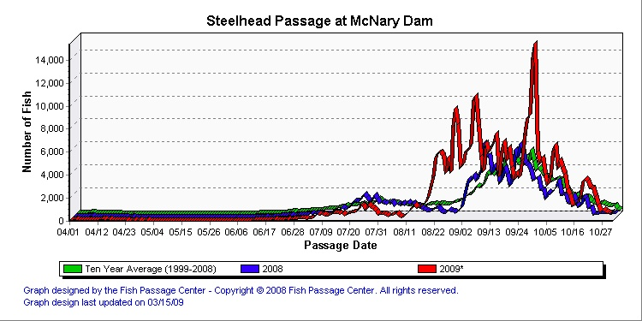
Comments from others:
USFWS- I support the following change forms.
NOAA- Agree with the proposed changes.
CRITFC- agree with.
BPA recommends this to be placed on an FPOM agenda for additional discussion
NWW- Adult fish passage timing is considered in all unit operations at McNary.
Record of Final Action:
☺☺☺☺☺☺☺☺☺☺☺☺☺☺☺☺☺☺☺☺☺☺☺☺☺☺☺☺☺☺☺☺☺☺☺☺☺☺
Change Request Number:
Date: February 5, 2010
Proposed by: David Benner, FPC
Location of Change- MCN 3.2.2.3
Proposed Change: 3.2.2.3. South Shore Auxiliary Water Supply System. The south shore auxiliary water is made up of a combination of gravity flow from the forebay and pumped water from the tailrace. The gravity flow supplies the diffusers above weir 253 (diffusers 7 through 14) and the pumps supply the diffusers below weir 253 (diffusers 1 through 7 and the main unit diffusers). … If one pump fails, the other two pumps will be operated to maintain the facilities within criteria. If two pumps fail and the outages are expected to be long-term then the middle eight of twelve open floating orifices should be closed (4,8,14,21,26,32,37,41) before closing main entrances, if extra water is still needed, NFE3 will be closed and SFE1, SFE2, and NFE2 will be operated as deep as possible to maintain the 1' to 2' head differential. If two pumps fail and the outages are expected to be short-term then NFE3 will be closed and SFE1, SFE2, and NFE2 will be operated as deep as possible to maintain the 1' to 2' head differential. If all three pumps fail and the outage is expected to last six days or longer, the powerhouse transportation channel will be bulkheaded off at the junction pool and SFE1 and SFE2 operated a deep as possible and to maintain the 1' to 2' head differential….
Reason for Change: McNary has 12 orifice gates operating (1,3,4,8,14,21,26,32,37,41,43,44). Under long-term pump outages, some of these orifices (if not all) should be closed before main entrances.
Comments from others:
USFWS- I think these change forms need more discussion at FPOM.
NOAA- Closing floating orifices. Recommendation makes sense but needs discussion in FPOM regarding feasibility.
CRITFC- sounds good but should discuss at FPOM for final approval
BPA has no concerns with this change
NWW- Brad Eby, CLOSING ALL OF THE FLOATING ORIFICE GATES IS NOT PRACTICAL ON A SHORT TERM BASIS. EACH GATE REQUIRES REMOVING THE GATE, DISASSEMBLING INTO IT'S THREE COMPONENTS, AND THEN TRANSPORTING IT TO YARD FOR STORAGE. THEN TRANSPORTING 6 PRECAST CONCRETE BULKHEADS FOR EACH GATE FROM THE YARD AND INSTALLING THEM WITH CRANE AND THREE MEMBER CREW. I THINK IT COULD TAKE MOST OF A WEEK TO GET ALL 12 FLOATING GATES CLOSED
TO CLOSE THE NORTH NFE ENTRANCES TAKES THE CLICK OF A COMPUTER MOUSE AND ABOUT 10 MINUTES RUN TIME TO RAISE THE GATES OUT OF THE WATER. DON'T CHANGE ANYTHING ON THIS ONE. I THINK IT'S FINE THE WAY IT'S WRITTEN NOW
Record of Final Action:
☺☺☺☺☺☺☺☺☺☺☺☺☺☺☺☺☺☺☺☺☺☺☺☺☺☺☺☺☺☺☺☺☺☺☺☺☺☺
Change Request Number:
Date: February 5, 2010
Proposed by: David Benner, FPC
Location of Change- IHR 4.3
Proposed Change: 4.3. Turbine Unit Maintenance. The project turbine unit maintenance schedule will be reviewed annually by project and Operations Division biologists for fish impacts. If possible, maintenance of priority units will be scheduled for non-fish passage periods, or when there are low numbers of fish passing the project. Each turbine unit requires annual maintenance that may take from several days to two weeks. Annual maintenance of all turbine units is normally scheduled during the mid-July to late November time frame. The maintenance of priority units for adult passage is preferably completed in November and December but can be completed in mid-August , if few adults are migrating or are expected to approach Ice Harbor Dam (based on counts downriver). Impacts to migrating adults should be minimized. Turbine units may occasionally require overhauls to repair major problems with the turbine or generator. Overhauls may take over one year to accomplish. Turbine units, governors, exciters, and control systems require periodic maintenance, calibration, and testing which may take them outside of the 1% turbine efficiency range. This work will be scheduled in compliance with BPA load shaping guidelines (Appendix C) to minimize impacts on juvenile fish.
Reason for Change: 2009 saw a sharp increase in steelhead numbers in mid-August at IHR. McNary had language that also had November or December as options for maintaining priority units for adult passage.

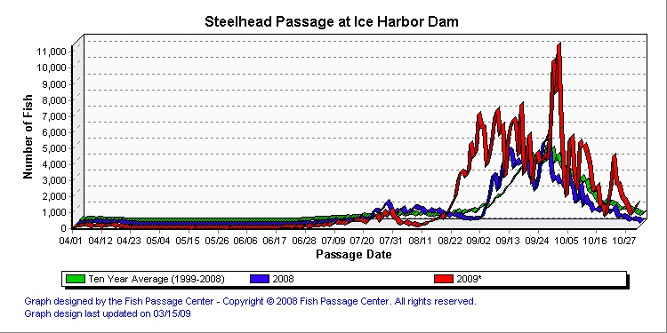

Comments from others:
USFWS-I support the following change forms.
NOAA- The following need further FPOM discussion before changing because I either disagree with the change or see no reason for the change. Thanks bill hevlin
BPA does not agree with the change. Recommendation is to place this on an FPOM agenda for additional discussion.
NWW- Adult fish passage timing is considered in all unit operations at Ice Harbor
Record of Final Action:
☺☺☺☺☺☺☺☺☺☺☺☺☺☺☺☺☺☺☺☺☺☺☺☺☺☺☺☺☺☺☺☺☺☺☺☺☺☺
Change Request Number:
Date: February 5, 2010
Proposed by: David Benner, FPC
Location of Change- IHR 2.3.1.2.a.2
Proposed Change: 2. Remove debris from trashracks as required to maintain less than 1' of additional drawdown in gate slots (relative to the drawdown with a clean screen). Additional raking may be required when heavy debris loads are present in the river. Coordinate turbine unit outages with other project work activities, if possible, to minimize turbine unit outages during the spring.
Reason for Change: This section needed a reference for “additional drawdown.”
Comments from others:
USFWS-I support the following change forms.
NOAA- These change forms are okay. Thanks bill hevlin
BPA has no concerns with this change
NWW- THIS IS CURRENTLY COMPARED TO A BASELINE READING THAT IS TAKEN AT THE BEGINNING OF THE SEASON SOON AFTER THE TRASHRACKS ARE RACKED. WHAT HAPPENS HERE IS THAT THERE IS AN ACCUMULATION OF DEBRIS AT THE BOTTOM OF SOME OF THE TRASH RACKS THAT CAN NOT BE REMOVED BY THE TRASH RACK RAKE. ESSENTIALLY IT JUST KEEPS PUSHING IT AND PACKING IT DOWN. SO, I WOULD NOT SAY RELATIVE TO A CLEAN SCREEN BECAUSE WE DO NOT KNOW WHAT THAT IS AND IT VARIES FOR EACH UNIT. MIGHT INCLUDE MENTION OF THE BASELINE READING
Record of Final Action:
☺☺☺☺☺☺☺☺☺☺☺☺☺☺☺☺☺☺☺☺☺☺☺☺☺☺☺☺☺☺☺☺☺☺☺☺☺☺
Change Request Number:
Date: February 8th, 2010
Proposed by: David Benner, FPC
Location of Change- LMN 4.3
Proposed Change: 4.3. Turbine Unit Maintenance. The project turbine unit maintenance schedule will be reviewed annually by project and Operations Division biologists for fish impacts. If possible, maintenance of priority units will be scheduled for non-fish passage periods, or when there are low numbers of fish passing the project. Each turbine unit requires annual maintenance that may take from several days to two weeks. Annual maintenance of all turbine units is normally scheduled during the mid-July to late November time frame. The maintenance of priority units for adult passage is preferably completed in November and December but can be completed in mid-August , if few adults are migrating or are expected to approach LMN (based on counts downriver). Impacts to migrating adults should be minimized. Turbine units may occasionally require overhauls to repair major problems with the turbine or generator. Overhauls may take over one year to accomplish. Turbine units, governors, exciters, and control systems require periodic maintenance, calibration, and testing which may take them outside of the one percent best efficiency range. This work will be scheduled in compliance with BPA load shaping guidelines (Appendix C) to minimize impacts on juvenile fish. Transformers are Doble tested every 3 years. Testing may need to be more frequent if there is a known problem with a transformer. These tests normally take 2 to 3 workdays. To conduct the testing, the distribution lines have to be disconnected from the transformers and normal generation stopped. One turbine unit will operate in a speed-no-load condition to provide project power and operation of fish passage facilities. Spill may be provided to meet minimum required project discharges during the testing hours. The Doble tests are normally scheduled for the August or early September time period to minimize impacts on adult and juvenile fish passage. If doble testing impacts priority units for fish passage, adult passage timing should be considered. Impacts to migrating adults should be minimized.
Reason for Change: Steelhead passage can be significant in late August or early September.
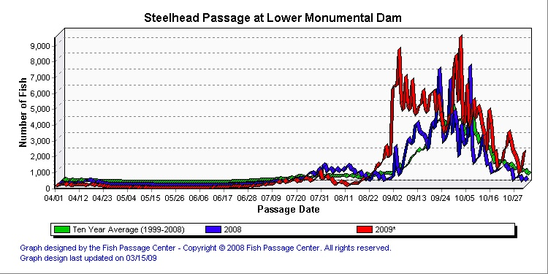
Comments from others:
USFWS- I support the following change forms, but ask why aren't the same concerns with Dobel testing in the appropriate sections for IHR, MCN, JDA, TDA, and BON?
NOAA- To have all these change forms reviewed and commented on by Friday the 12th seems a bit rushed to me. But maybe they have been available for us for a couple weeks or so and I misplaced them. If they were only available this week to begin with, then we need a couple weeks to review and comment, which would mean the following Friday, Feb. 19, which is still rushed considering that we all have many other things to do. If that timing does not fit in to your schedule to finish the document for this year then I see nothing wrong with placing these on the shelf as a priority for next year. Thanks bill hevlin
BPA recommends this to be placed on an FPOM agenda for additional discussion.
NWW- Adult fish passage timing is considered in all unit operations and forced outages at Lower Monumental. Doble testing must be done in August to early September because conditions of humidity and temperature are critical for the testing. So the last comment on the second change request is moot and the answer is "NO".
Record of Final Action: not approved for 2010 FPP.
☺☺☺☺☺☺☺☺☺☺☺☺☺☺☺☺☺☺☺☺☺☺☺☺☺☺☺☺☺☺☺☺☺☺☺☺☺☺
Change Request Number:
Date: February 8th, 2010
Proposed by: David Benner, FPC
Location of Change- LMN 2.3.1.2.g
Proposed Change: g. Removable Spillway Weir (RSW). Operational criteria for the new RSW are …xxx.
Reason for Change: Operational criteria for the RSW should be available.
Comments from others:
USFWS-I support the following change forms.
NOAA- To have all these change forms reviewed and commented on by Friday the 12th seems a bit rushed to me. But maybe they have been available for us for a couple weeks or so and I misplaced them. If they were only available this week to begin with, then we need a couple weeks to review and comment, which would mean the following Friday, Feb. 19, which is still rushed considering that we all have many other things to do. If that timing does not fit in to your schedule to finish the document for this year then I see nothing wrong with placing these on the shelf as a priority for next year. Thanks bill hevlin
BPA concurs with the comment.
Record of Final Action:
☺☺☺☺☺☺☺☺☺☺☺☺☺☺☺☺☺☺☺☺☺☺☺☺☺☺☺☺☺☺☺☺☺☺☺☺☺☺
Change Request Number:
Date: February 8th, 2010
Proposed by: David Benner, FPC
Location of Change- LGS 4.3
Proposed Change: 4.3. Turbine Unit Maintenance. The project turbine unit maintenance schedule will be reviewed annually by project and Operations Division biologists for fish impacts. If possible, maintenance of priority units will be scheduled for non-fish passage periods, or when there are low numbers of fish passing the project. Each turbine unit requires annual maintenance that may take from several days to two weeks. Annual maintenance of all turbine units is normally scheduled during the mid-July to late November time frame. The maintenance of priority units for adult passage is preferably completed in November and December but can be completed in mid-August , if few adults are migrating or are expected to approach LGS (based on counts downriver). Impacts to migrating adults should be minimized Turbine units may occasionally require overhauls to repair major problems with the turbine or generator. Overhauls may take over one year to accomplish. Turbine units, governors, exciters, and control systems require periodic maintenance, calibration, and testing which may take them outside of the one percent best efficiency range. This work will be scheduled in compliance with BPA load shaping guidelines (Appendix C) to minimize impacts on juvenile fish. Transformers are Doble tested every 3 years. Testing may need to be more frequent if there is a known problem with a transformer. These tests normally take 2 to 3 workdays. To conduct the testing, the transmission lines have to be disconnected from the transformers and normal generation stopped. One turbine unit will operate in a speed-no-load condition to provide project power and operation of fish passage facilities. Spill may be provided to meet minimum required project discharges during the testing hours. The Doble tests are normally scheduled for the August or early September time period to minimize impacts on adult and juvenile fish passage. If doble testing impacts priority units for fish passage, adult passage timing should be considered. Impacts to migrating adults should be minimized.
Reason for Change: The following plot shows adult steelhead passage in 2008, 2009, and the 10yr average. From this plot, the early September time period does not appear to be a good time to be doble testing if it means stopping generation from priority units.

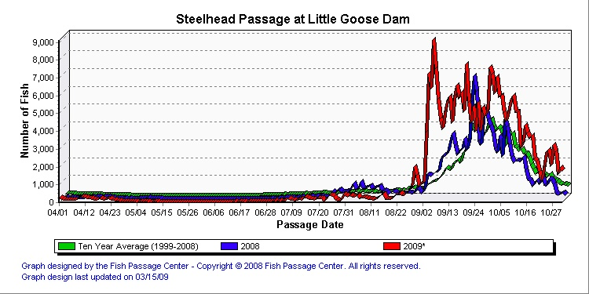
Comments from others:
USFWS- I support the following change forms, but ask why aren't the same concerns with Dobel testing in the appropriate sections for IHR, MCN, JDA, TDA, and BON?
NOAA- The following need further FPOM discussion before changing because I either disagree with the change or see no reason for the change. Thanks bill hevlin
BPA recommends this to be placed on an FPOM agenda for additional discussion.
NWW- Operating priority is 1, 2, 3, 4, 5 and 6. Turbine unit maintenance begins in July - adult fish passage is low, flows are low and one or two turbine units operating. The project should complete annuals in logical order so that the lowest priority units (6, 5, 4) are serviced during September and October when adult fish passage is high. The project needs July through November to complete all turbine unit maintenance. December is too late and we're into pulling ESBS, winter maintenance and holidays. The 6 year overhaul unit should be completed last, Mid- Oct thought the end of November. Unit priority does not take precedence - it takes 6 weeks.

The third request involving Doble test - sounds like we shouldn't perform doble tests September due to increased migrating adult fish passage. This makes since so I see no reason to restrict the tests to alternating years (T1/T2) and mid August.
“4.3. Turbine Unit Maintenance. The project turbine unit maintenance schedule will be reviewed annually by project and Operations Division biologists for fish impacts. If possible, maintenance of priority units will be scheduled for non-fish passage periods, or when there are low numbers of fish passing the project. Each turbine unit requires annual maintenance that may take from several days to two weeks. Annual maintenance of all turbine units is normally scheduled during the mid-July to late November time frame. The maintenance of low priority turbine priority units (i.e. 6, 5, 4) for adult passage should be completed in September and October to reduce impacts to increased migrating adult fish. The unit undergoing 6-year overhaul should be completed last beginning in mid October to late November. Turbine units may occasionally require overhauls to repair major problems with the turbine or generator.”
Record of Final Action:
☺☺☺☺☺☺☺☺☺☺☺☺☺☺☺☺☺☺☺☺☺☺☺☺☺☺☺☺☺☺☺☺☺☺☺☺☺☺
Change Request Number:
Date: February 8th, 2010
Proposed by: David Benner, FPC
Location of Change- LGS 2.3.1.2.a.3
Proposed Change: 2.3.1.2. Fish Passage Period (April 1 through December 15).
a. Forebay Area and Intakes.
1. Remove debris from forebay. All floating debris will be removed whenever two acres of debris accumulates in the spring and one acre in the summer and fall.
2. Log drawdown differentials in bulkhead slots at least once a week.
3. Remove debris from forebay and trashracks as required to maintain less than 1' of additional drawdown in gate slots (relative to the drawdown with a clean screen). Additional raking may be required when heavy debris loads are present in the river or when fish condition requires it.
Reason for Change: This section needed a reference for “additional drawdown.”
Comments from others:
USFWS-I support the following change forms.
NOAA- These change forms are okay. Thanks bill hevlin
BPA has no concerns with this change
NWW Fisheries- George Melanson, Fishery Biologist, “The first FPP Change. There appears to be no reference. The reference is the initial drawdown reading conducted in early April, after ESBS are deployed, prior to debris arrival, and after MOP is established. So see attached, I have edited below.”
3. Remove debris from forebay and trashracks as required to maintain less
than 1' of additional drawdown from the initial drawdown measurement obtained in early April after ESBS deployment, MOP is achieved and prior to debris arrival in gate slots. Additional raking may be required when heavy debris loads are present in the river or when fish condition requires it.
Record of Final Action:
☺☺☺☺☺☺☺☺☺☺☺☺☺☺☺☺☺☺☺☺☺☺☺☺☺☺☺☺☺☺☺☺☺☺☺☺☺☺
Change Request Number:
Date: February 8th, 2010
Proposed by: David Benner, FPC
Location of Change- LGR 3.2.2.2
Proposed Change: 3.2.2.2. Auxiliary Water Supply System. Three electric pumps supply the auxiliary water for the fish ladder and the powerhouse collection system. During normal operations and most flow conditions, two pumps are capable of providing the required flows. If a pump fails during the two-pump operation, the pump on standby will be operated to make up the flows. If two pumps fail and the outage is expected to be long term, the floating orifices should be closed in the following order: OG-4, OG-7, OG-10, and OG-1. If fishway criteria still cannot be met, NSE 2 and NPE 2 will be closed and NPE 1 raised in 1' increments to provide the required 1' to 2' head differential. If the head cannot be maintained by the time the top of the weir reaches 5', then SSE 1 and SSE 2 should be raised in 1' increments until 5' below tailwater is reached. If all three pumps fail, NSE 1 and NPE 1 should be closed, the powerhouse collection channel bulkheaded off at the junction pool, and SSE 1 and SSE 2 operated at 6' below tailwater regardless of the head.
Reason for Change: In the event of a long term outage of multiple pumps, floating orifice gates should be closed before main entrances.
Comments from others:
USFWS- I think these change forms need more discussion at FPOM.
NOAA- The following need further FPOM discussion before changing because I either disagree with the change or see no reason for the change. Thanks bill hevlin
BPA has no concerns with this change
LWG Fisheries- Need to clarify what is a long-term outage. The present protocol of closing NSE- 2 and NPE 2 and raising NPE 1 in one foot increments to provide the required 1' - 2' of head differential appears to be the best course of action. An operator can do this independent of other help should both fish pumps fail. Closing the floating orifice gates (OG-1, OG-4, OG-7, and OG-10) would require the assistance of a fork lift operator and crew members. It takes some time to assemble a crew. Such individuals are not normally available on weekends or after hours.
Record of Final Action:
☺☺☺☺☺☺☺☺☺☺☺☺☺☺☺☺☺☺☺☺☺☺☺☺☺☺☺☺☺☺☺☺☺☺☺☺☺☺
Change Request Number:
Date: February 8th, 2010
Proposed by: David Benner, FPC
Location of Change- LGR 4.3
Proposed Change: 4.3. Turbine Unit Maintenance. The project turbine unit maintenance schedule will be reviewed annually by project and Operations Division biologists for fish impacts. If possible, maintenance of priority units will be scheduled for non-fish passage periods, or when there are low numbers of fish passing the project. Each turbine unit requires annual maintenance that may normally take 2 to 5 weeks. Annual maintenance of all turbine units is normally scheduled during the mid-July to late November time frame. The maintenance of priority units for adult passage is normally conducted during mid-August, when fewer adults are migrating, to minimize impacts on migrating adults. Turbine units may occasionally require overhauls to repair major problems with the turbine or generator. Overhauls may take over one year to accomplish. Turbine units, governors, exciters, and control systems require periodic maintenance, calibration, and testing which may take them outside of the 1% turbine efficiency range. This work will be scheduled in compliance with BPA load shaping guidelines (Appendix C) to minimize impacts on juvenile fish. Transformers are Doble tested every 3 years. Testing may need to be more frequent if there is a known problem with a transformer. These tests normally take 3 to 5 workdays. To conduct the testing, the transmission lines have to be disconnected from the transformers and normal generation stopped. One turbine unit will operate in a speed-no-load condition to provide project power and operation of fish passage facilities. Spill may be provided to meet minimum required project discharges during the testing hours. The Doble tests are normally scheduled for the August or early September time period to minimize impacts on adult and juvenile fish passage. If doble testing impacts priority units for fish passage, adult passage timing should be considered. Impacts to migrating adults should be minimized.
Reason for Change:The following plot shows adult steelhead passage in 2008, 2009, and the 10yr average at LGR. From this plot, the early September time period does not appear to be a good time to be doble testing if it means stopping generation from priority units.

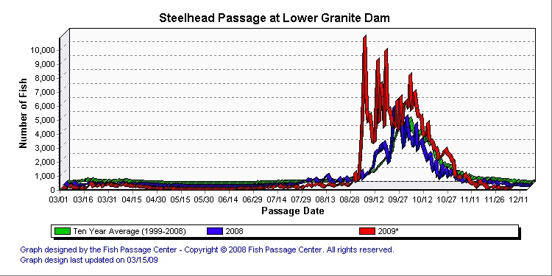
Comments from others:
USFWS- I support the following change forms, but ask why aren't the same concerns with Dobel testing in the appropriate sections for IHR, MCN, JDA, TDA, and BON?
NOAA- These change forms are okay. Thanks bill hevlin
BPA recommends this to be placed on an FPOM agenda for additional discussion.
NWW- Adult fish passage timing is considered in all unit operations at Lower Granite. Doble Testing normally takes place in August and very seldom gets into September. During 2010 Doble Testing at Lower Granite is scheduled for the August 16-20 time period. With the exception of 2009, per the FPC's graph it would appear that steelhead passage does not pick up until nearly mid-September.
NWW- Reject this change.
Record of Final Action:
☺☺☺☺☺☺☺☺☺☺☺☺☺☺☺☺☺☺☺☺☺☺☺☺☺☺☺☺☺☺☺☺☺☺☺☺☺☺
Change Request Number:
Date: February 8th, 2010
Proposed by: David Benner, FPC
Location of Change- LGR 2.3.2.2.n
Proposed Change: n. Adult Trap Holding Tanks. Protocols for operating the adult trap for research and other activities are covered in Appendix G. This criterion supplements that appendix and governs use of the holding tanks for research or broodstock collection and the water supply for the tanks. The water supply for the trap comes from the diffuser water supply at the top of the ladder and trap operations can affect the amount of water in the ladder proper. Operating all six holding tanks may require that modifications be made to the auxiliary water supply to diffuser #14.
1. Prior to and during the period of use of any holding tanks at the Adult Trap, the COE should inspect and clean if necessary the intake to the diffuser #14 auxiliary water supply. Additionally, the COE should inspect and repair potential sources of leakage in the diffuser #14 water supply.
2. No holding tanks can be used prior to September 1 of each year if their usage affects the amount of water passing down the fish ladder and a water depth of less than 12 inches of water is maintained over the ladder weirs.
3. After September 1 of each year, the two smaller of the six holding tanks only may be used to hold adult fish, for hatchery broodstock or other research needs, if the use of more tanks will limit the ability of the LGR fish ladder to meet its depth over ladder weir criteria.
.
4. The configuration and operation of the adult fish trap was reviewed during winter maintenance period 2009. At this time it was discovered that the diffuser #14 AWS was limited by a stuck valve. This valve has been repaired and it is anticipated that this repair will alleviate past issues with meeting both the needs of the adult fish trap and the needs of the fish ladder. However, if further changes are needed , these will be coordinated through CENWW-OD-T, in consultation with NOAA Fisheries, and the regional members of FPOM. In-season operational changed that deviate from MOP will be coordinated through TMT.
Reason for Change:This language needed updating to reflect work performed in 2009.
Comments from others:
USFWS-I support the following change forms.
NOAA- needs feedback from the NOAA operators of the Lower Granite trap before changing. Thanks bill hevlin
BPA recommends this to be placed on an FPOM agenda for additional discussion.
NWW Fisheries- Diffuser 14 AWS was not limited by a stuck valve. It was limited by the larger housing constraint (more area restricting flow) of the valve that was in the pipe. Repairs to the valve should eliminate the need to do any in-season work. However, you never know what could develop and cause an emergency situation. It might be wise to stay with the current wording.
Mike Halter, Project fishery Biologist, “Diffuser 14 AWS was not limited by a stuck valve. It was limited by the larger housing constraint (more area restricting flow) of the valve that was in the pipe. Repairs to the valve should eliminate the need to do any in-season work.”
CENWW proposes the following changes to the FPP:
- Additional holding tanks may be used if modifications made to the diffuser #14 water supply that allow a water depth of 12 inches or greater over the ladder weirs in addition to meeting the needs of the additional tanks.
- Current configuration and operation of the adult fish trap will be reviewed during 2010.. If any changes are needed, these will be coordinated through CENWW-OD-T, in consultation with NOAA Fisheries, and the regional members of FPOM. In-season operational changed that deviate from MOP will be coordinated through TMT.
Record of Final Action:
☺☺☺☺☺☺☺☺☺☺☺☺☺☺☺☺☺☺☺☺☺☺☺☺☺☺☺☺☺☺☺☺☺☺☺☺☺☺
Change Request Number:
Date: February 8, 2010
Proposed by: David Benner, FPC
Location of Change- Table LWG-4
Proposed Change: Table LWG-4. Adult count periods and peak migration timing at Lower Granite Dam from 1975-2008 (2009?) based on fish counts.
Date of Peak Passage Species Counting
Period Earliest Latest
Spring Chinook 3/1 - 6/17 4/26 5/27
Summer Chinook 6/18 - 8/17 6/18 7/17
Fall Chinook 8/18 - 12/31 9/5 10/6
Steelhead 3/1 - 12/31 9/3 10/16
Sockeye 3/1 - 12/31 7/1 7/19
Reason for Change: Tables 2 and 3 refers to the video counts (0600-1600) occurring through December 31st. Table LWG-4 says that fall chinook, steelhead, and sockeye counts only extend through December 15th.
Comments from others:
USFWS-I support the following change forms.
NOAA- These change forms are okay. Thanks bill hevlin
BPA has no concerns with this change
NWW- Changes were made to the 2010 draft prior to this FPP change form.
- I trust we are talking about LWG-3 and LWG-4 (not Tables 2 and 3 as stated above) the addition of count periods and peak to the title of the table is reasonable.
- Change the count end period of sockeye, steelhead and fall Chinook to 12/31 is reasonable, but you may not find sockeye to count past 10/31.
Record of Final Action:
☺☺☺☺☺☺☺☺☺☺☺☺☺☺☺☺☺☺☺☺☺☺☺☺☺☺☺☺☺☺☺☺☺☺☺☺☺☺
Change Request Number: 11 IHR 001
Date: 3-10-2010
Proposed by: Mark Plummer, Ice Harbor Project Fisheries Biologist
Existing Condition: Primary Dewatering Screen Cleaner Timing.
2010 FPP IHR-section 2.3.1.2 d. Dewatering Structure paragraph 1.
- Trash sweep operating correctly. The frequency of sweep should be set as necessary to maintain a clean screen, with a minimum operation of at least once per hour. If automated cleaning system problems occur, operate manually at least once per work shift, or more as necessary, to maintain a clean screen.
Proposed Change to:
- The Project Biologist shall determine the frequency of operation of the trash sweep. The sweep should operate at a frequency to maintain a clean screen given present debris loads. If automated cleaning system problems occur, operate manually at least once per work shift, or more as necessary, to maintain a clean screen.
Reason for Change:
The current FPP criterion minimum frequency setting of once per hour is causing excessive and unnecessary wear on the trash sweep leading to early failure. The possibility of large amounts of debris in the river that could cause plugging of the screen or descaling of fish occurs during the spring run off. Typically this is when sweeping of the screen needs to be more frequent. During the summer months, debris movement in the river usually follows a significant rain occurrence. The frequency of the screen cleaner can be adjusted during the times of low debris to cycle fewer times to maintain a clean screen. This will reduce the amount of wear on the equipment and prolong the need for unscheduled maintenance and outages. In addition, this change will put Ice Harbor more in agreement with what is in the 2010 FPP for Little Goose and McNary facilities.
☺☺☺☺☺☺☺☺☺☺☺☺☺☺☺☺☺☺☺☺☺☺☺☺☺☺☺☺☺☺☺☺☺☺☺☺☺☺
Change Request Number: 11 LMN 001
Date: April 6, 2010
Proposed by: CENWW –OD-T
Proposed Change:
Lower Monumental spill discharge table - revisions
Reason for Change:
For several days at the end of October and the first of November 2008, Lower
Monumental dam maintained a steady operation that included spilling through six spill
bays. Reservoir Control Center (RCC) personnel observed that there was a discrepancy
between Little Goose outflow and Lower Monumental inflow and between Lower
Monumental outflow and Ice Harbor inflow numbers. An error in the reported spill at
Lower Monumental is the logical explanation for this discrepancy.
Project personnel measured the physical gate opening of Spillbay 8. Based on these measurements, it is apparent that the gate openings for Stops 1, 2, & 3 for Spillbay 8 are significantly greater than what is listed in Table 9 of the Water Control Manual for Lower Monumental. Gate opening measurements from Stop 4 and upwards are in close agreement with Table 9.
Comments from others:
Record of Final Action:
☺☺☺☺☺☺☺☺☺☺☺☺☺☺☺☺☺☺☺☺☺☺☺☺☺☺☺☺☺☺☺☺☺☺☺☺☺☺
Change Request Number: 11 LGS 001: LGS SW operations
Date: March 24, 2010 and revised on March 30, 2010
Proposed by: FPAC
Location of Change- LGS Section 2.3.1.2
Proposed Change:
Section 2.3.1.2. Fish Passage Period (April 1 through December 15)
g. Spillbay Weir (SW)

1. Spring fish passage season will start with the SW-LO in place unless the last flow forecast (STP) in March predicts total outflows at Little Goose dam to be less than 43 kcfs for at least one week. If so, begin the spill season with the SW in the high crest position (SW-HI).

2. Change to SW-LO when the flows exceed 43 kcfs and the most recent stream flow forecast projects seasonal flows above 70 kcfs for at least seven consecutive days. This change-over will take place within three normal working days after the above trigger conditions have been satisfied. During this change, the uniform spill pattern will be used. The trigger to change to the SW-LO configuration is further based on the following:
a. a review of the juvenile fish passage at Lower Granite and Little Goose dams to prevent changes during a peak in outmigration;
b. coordination with regional fish managers.

3. After the spring freshet has passed, the SW-HI will be installed after river discharge falls below 70 kcfs for three days in a row. The SW-LO will not be reinstalled for the rest of the season, even if river discharges subsequently increase above 70 kcfs. The trigger to change to the SW-HI configuration is further based on the following:
a. streamflow forecasts indicate continuing lower river discharges;
b. a review of the juvenile fish passage at Lower Granite and Little Goose dams to prevent changes during a peak in outmigration;
c. coordination with regional fish managers.
This change-over will take place within three normal working days after the above trigger conditions have been satisfied.

4. When daily average discharge drops below 32 kcfs in the summer while the SW-HI is installed and forecasts predict flows to remain below 32 kcfs for at least three days, the SW will be closed for the remainder of the spill season. The SW will be closed within three normal working days and coordinated through CENWW-OD-T.

5. Special turbine unit 1 operations will change from the upper 25% of the 1% of best efficiency range to the full 1% of best efficiency range when project discharge is below 38 kcfs and above 31 kcfs.

6. The uniform spill pattern, with no spillway weir operating, will be used as an alternate pattern when the spillway weir must be closed for any reason, such as when switching from SW-LO to SW-HI, or when the SW is removed from service due to low river flows.
Reason for Change:
FPAC desire to use the surface weir at Little Goose Dam if at all reasonably possible to increase surface passage, and the current FPP change form does not describe operations at flows between 26 to 36 Kcfs.
Comments from others:
Record of Final Action:
This FPP change form was discussed via teleconference on March 30, 2010. Representatives from CRITFC, IDFG, ODFW, USFWS, NOAA, BPA, FPC, and the Corps all agreed to this change for 2010 operations during the March 30 teleconference.
☺☺☺☺☺☺☺☺☺☺☺☺☺☺☺☺☺☺☺☺☺☺☺☺☺☺☺☺☺☺☺☺☺☺☺☺☺☺

